R E S U M E

D.SRINIVASULU 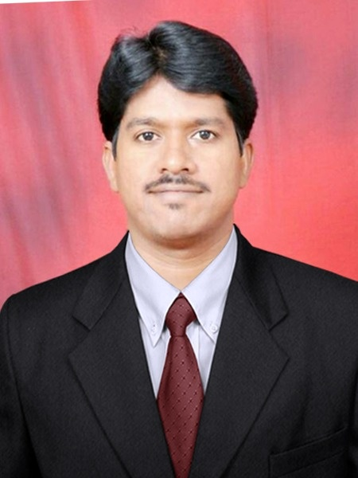

Mobile : 8247361837 D. No. 39/25-2-1A,
SKDR Colony,
Near RTC colony,
Kadapa,A.P-516002.
EMail: hodcse@klmcew.ac.in
____________________________________________________________________________

Professional Objective:

To serve the needs of Teaching Industry by striving hard and by Imparting Quality Education
to the people so as to improve the living standards of the people as well as community.
Summary of Educational Qualifications:
S. No. | Year | Qualification | Name of the Institution Studied | Board / University | Aggregate
1 | December 2022 | Pursuing Ph.D | Bharatiya Enginneering Science & Technology Innovation University (BESTIU) | Private university, Gorantla, Sri Satya Sai district, A.P | --
2 | December 2015 | M. Tech (C.S.E) | Sri Venkateswara Institute of Science & Technology,Kadapa | JNTUA,  Ananthapur | 75%
3 | April 2007 | B.Tech  (Computer Science & Engineering) | K.S.R.M College of Engineering, Kadapa | S. V. University, Tirupati | 60%
4 | March 2003 | Intermediate  (M.P.C) | Nagarjuna junior college, Kadapa | Board of Intermediate Education | 88.5%
5 | March 2001 | S.S.C | New Angels English Medium High School, Kadapa | Board of Secondary Education | 85%

Professional Experience:

- Having 10 years Of Experience in K.O.R.M College of Engineering,Kadapa as Assistant Professor from 2010- 2013 & 2015-2022.
- Worked as Officer In-charge,Exam section from 2017-2019 in K.O.R.M College Of Engineering,Kadapa.
- Worked as Head Of the Department, CSE from 2019-2022 in K.O.R.M College Of Engineering,Kadapa
- Present working in K.L.M college of Engineering for women, Kadapa as HOD,CSE from September 2022 to till date.

Additional Academic Activities:

- Placement Co-ordinator.
- JKC Co-ordinator
- Department sports Incharge.
- ECAP Co ordinator.
- Time table Co-ordinator
- Jnanabhumi Co-ordinator

ACHIEVEMENTS
- Published paper in international journal on “Automatic Detection of Lung Cancer through Pulmonary Nodules using Voxels Creation Mechanism”
- Participated in webinar on “Machine Learning using R-Programming Language” conducted by Vignan Institute of Management and Technology for women,Hyderabad
- Participated in webinar on “Data Analytics-Innovative Research methods and Data Analysis” conducted by Vignan Institute of Management and Technology for women,Hyderabad
- One of the author for the volume on “ ARTIFICIAL INTELLIGENCE FOR EVERYONE-APPLICATIONS AND IT TOOLS.”

PERSONAL DETAILS:

Gender : Male

Father's Name : D.Narasimhulu

Date of birth : 23/04/1986

Caste : SC-C

Religion : Hindu

Nationality : Indian

Languages Known : Telugu, English & Hindi

Permanent Address : D. No. 39/25-2-1A,
SKDR Colony,
Near RTC colony,
Kadapa,A.P-516002.

(D.SRINIVASULU)

